MANUAL

Trip Ticket

INSTALLATION

**Setting up XAMPP**

1. Download XAMPP from the apache friends and choose the download with the version of PHP that you need. (<https://www.apachefriends.org/download.html>)

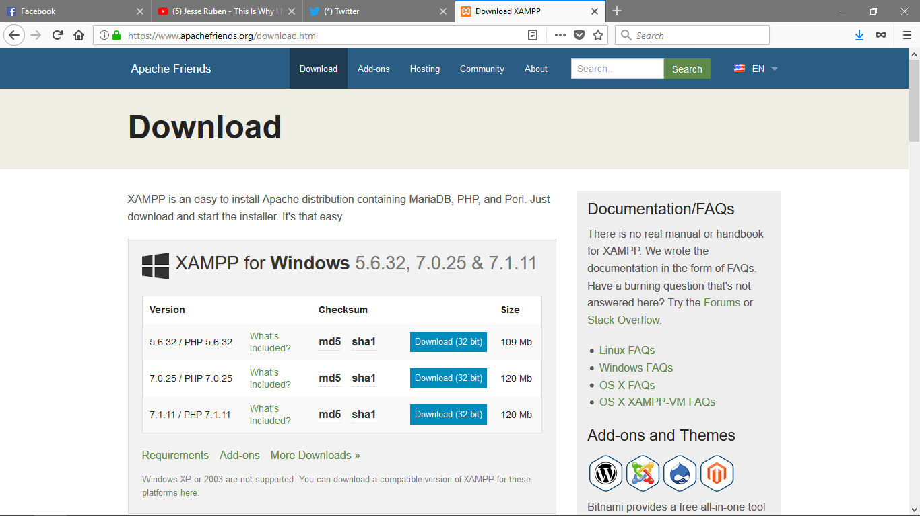

1. Click on the downloaded file to install.

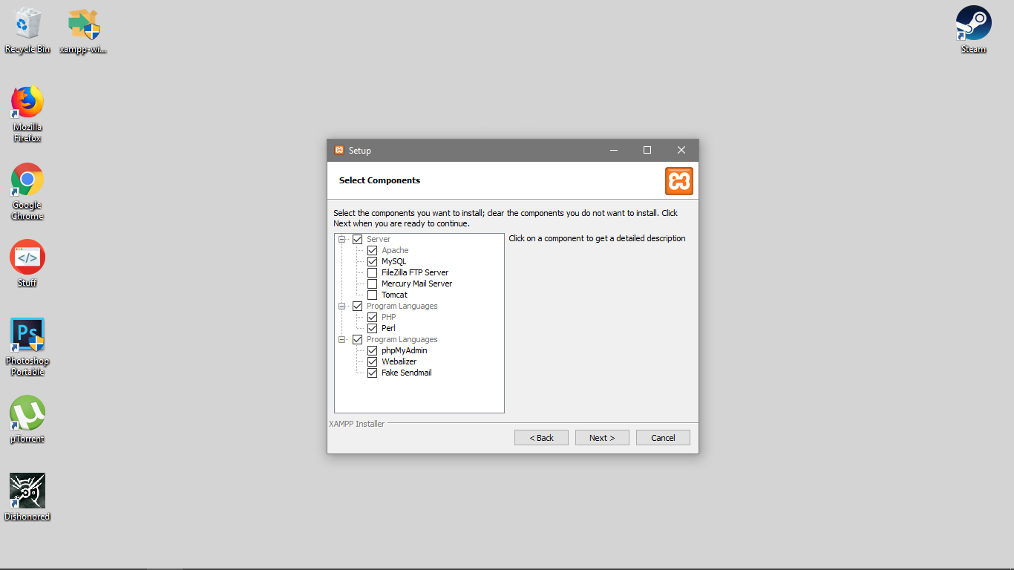

*(Accept the default settings or you can also uncheck FileZilla FTP Server, Mercury Mail Server, and Tomcat. We only need the Apache for the web server and the MySQL for the database server.)*

1. Choose the directory where you want to install XAMPP and install.

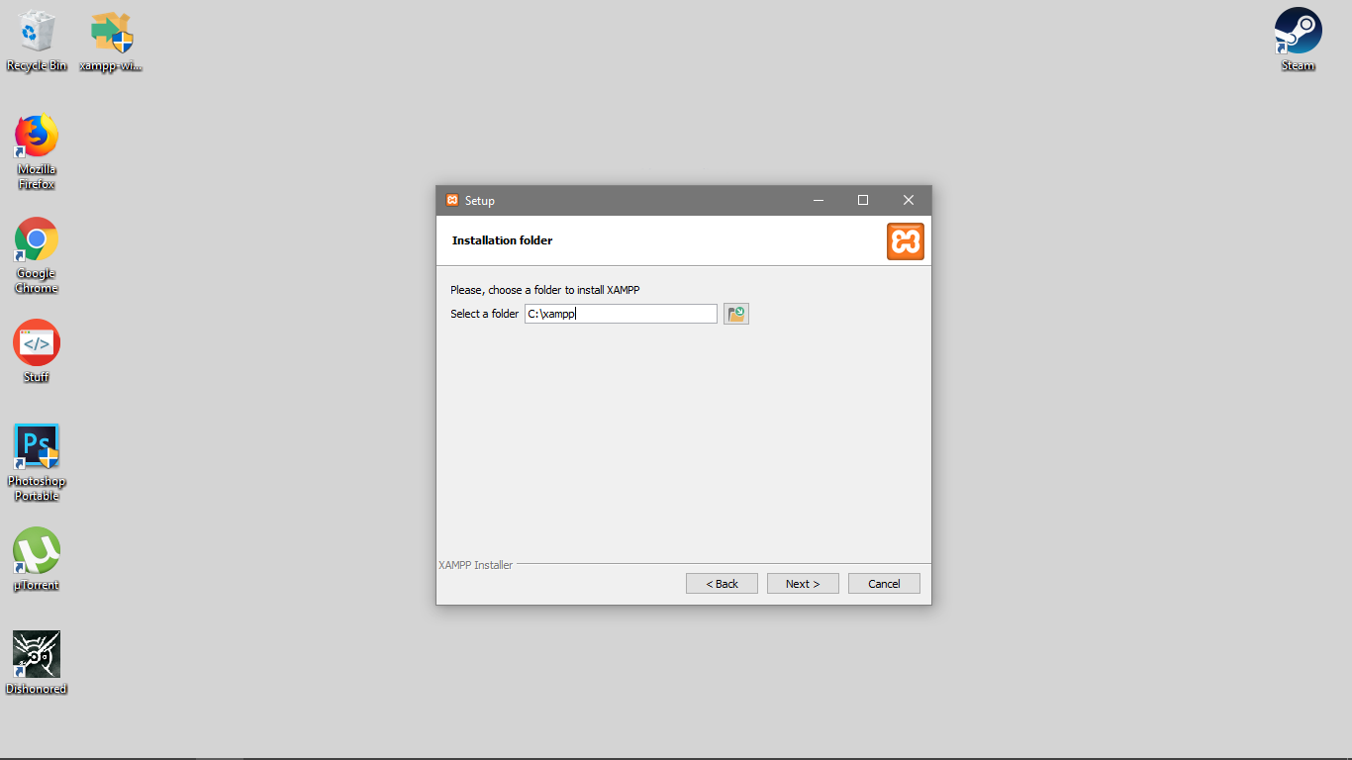

1. Open XAMPP Control Panel.

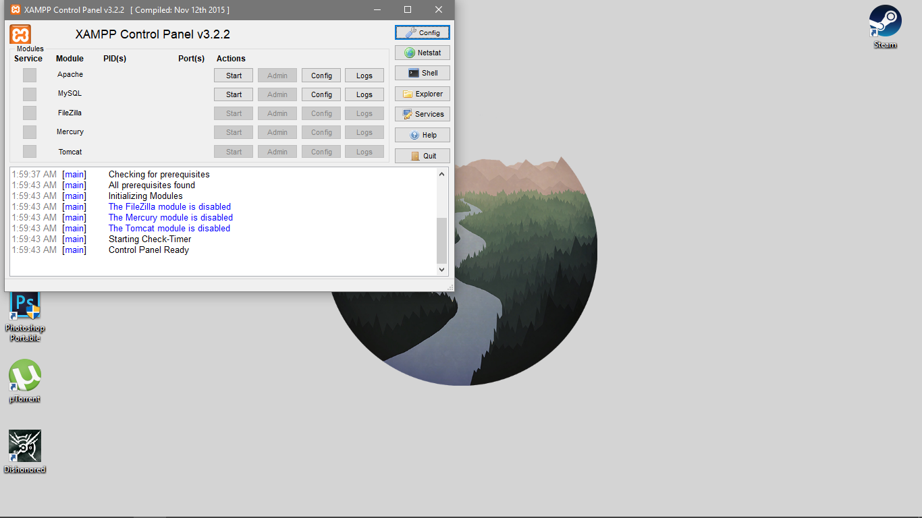

*(Start Apache and MySQL. Always start these two before accessing the webpages)*

**Importing Database**

1. Open your web browser (e.g. Google Chrome, Mozilla Firefox, etc.). In the address bar, type localhost/phpmyadmin.

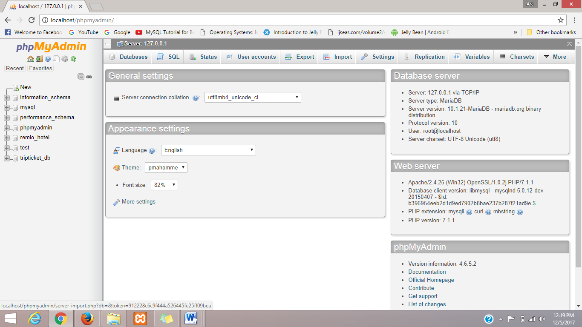

*(Click the import button)*

1. Below you will see a ‘choose file’ button. Click it. Select the file with a .sql extension.

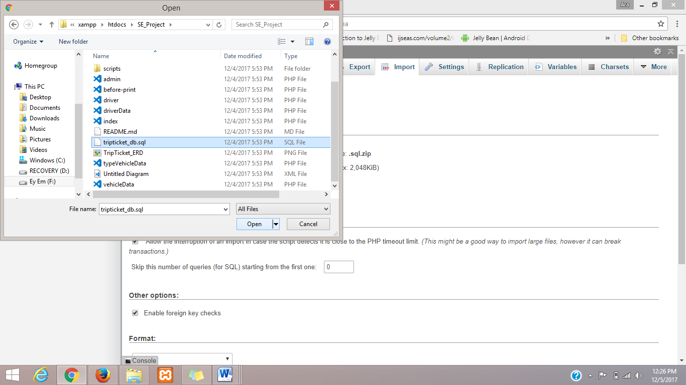

1. Open it. At the end of the page, you will see a go button. Click it.

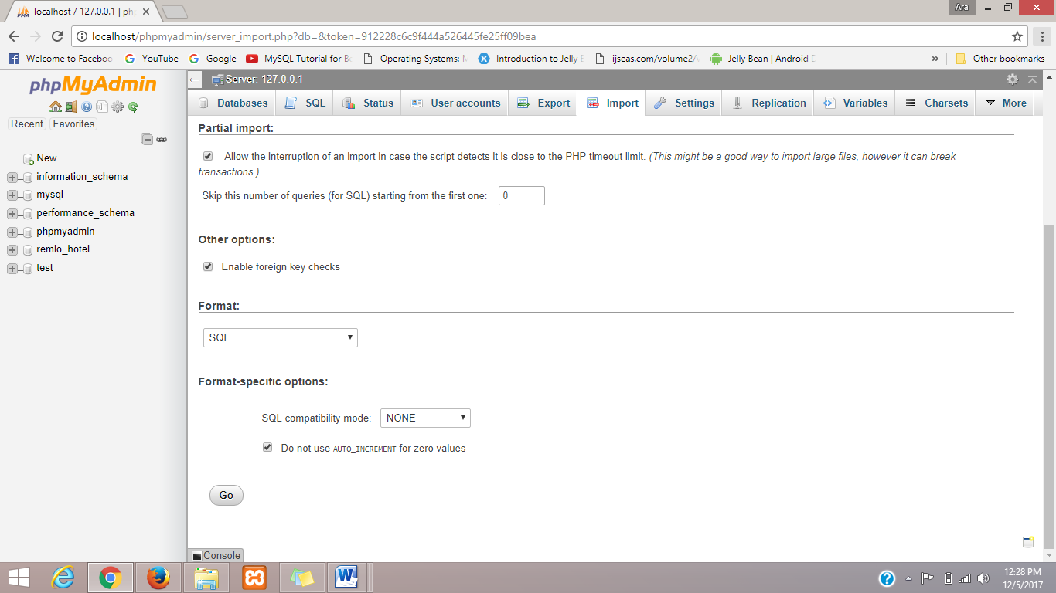

1. Wait for it to finish importing the database. Once finished, you can now see your imported database at the left corner of the page.

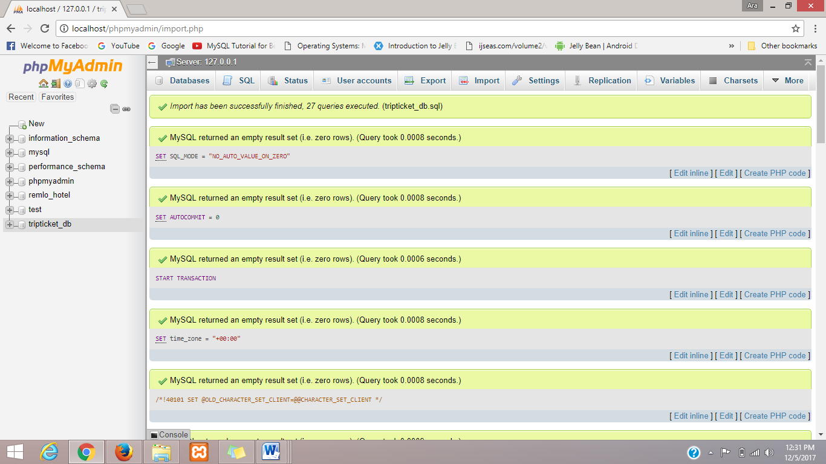

**Setting up Web Pages**

1. To be able to access the web app and to do local hosting, navigate to where you installed your XAMPP earlier. Inside the XAMPP folder, you can find a folder named ‘htdocs’.

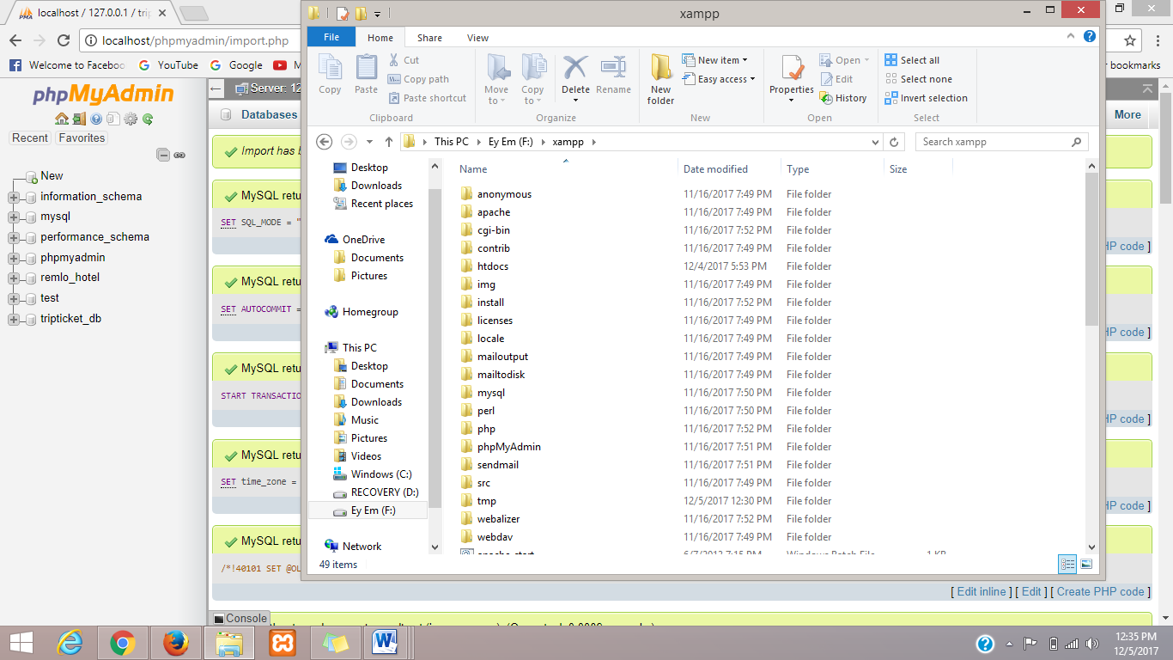

1. Open it and copy the folder that contains all the necessary files for the Web App into it.
2. After making sure that all the necessary files for the web app is inside the htdocs folder, you can now run/access the web pages.

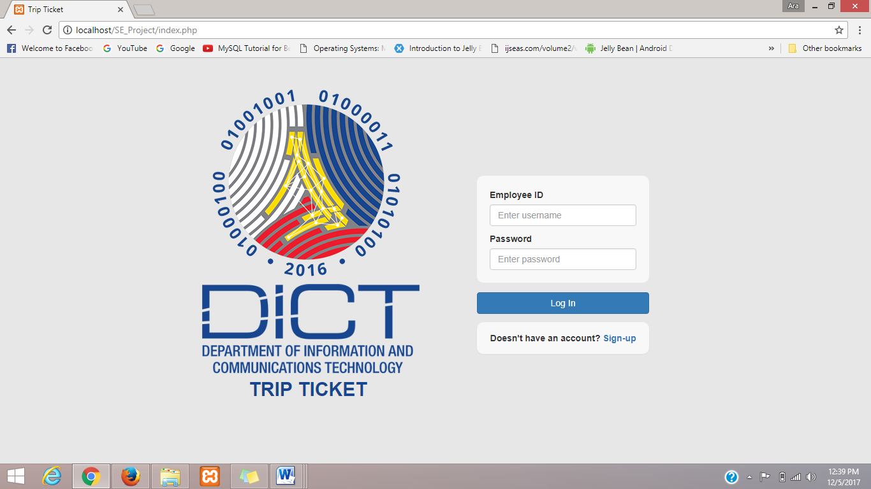

USER GUIDE

**Admin**

* Official Travel Report tab:

In here you can see the Monthly Official Trips made. You can also search Trips from a month to another on a specific year using the dropdown list at the upper right corner of the table, after choosing the months(from and to) and year, click search button.

Clicking on export button will download an excel file containing the necessary data for the Official Monthly Report. Reminder, before clicking Export, you must filter first on what month year you want to print. If not, it will display all the data to the exported excel file.

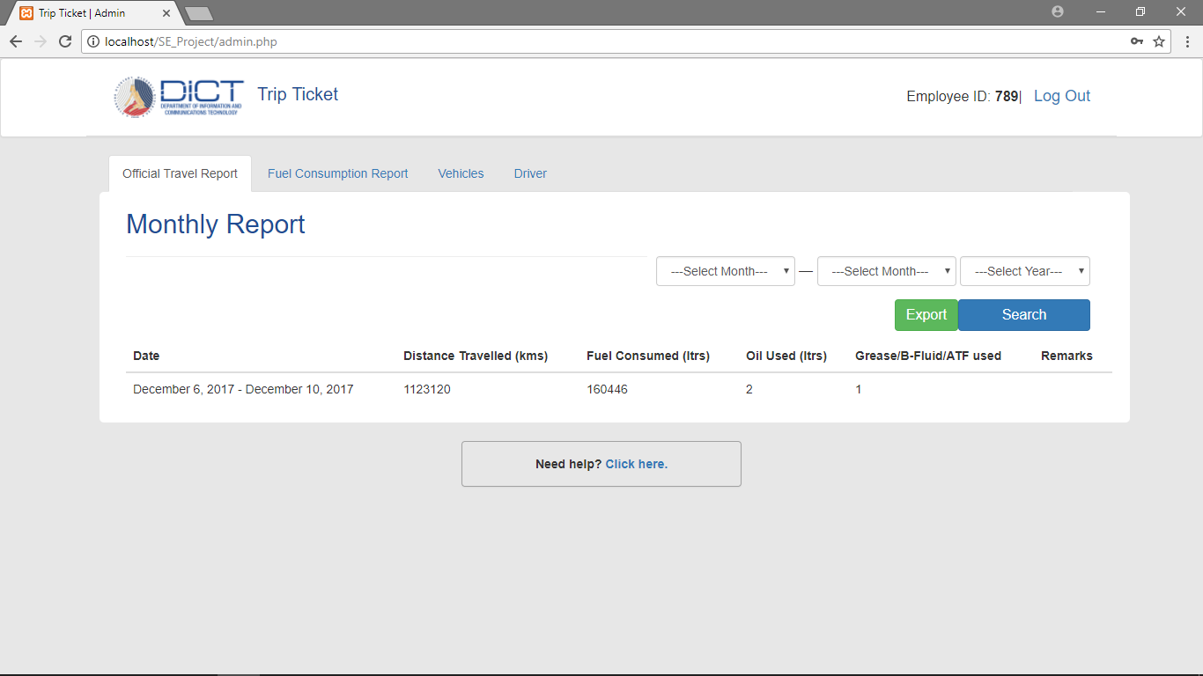

* Fuel Consumption Report tab:

Clicking on expert button will generate the Fuel Consumption’s Report and will download an excel file showing all the data required for the Yearly Report. Reminder, in order to Export properly, you must first filter out the year you want. To do this, simply choose the Year in the upper right tab and click search, then export.

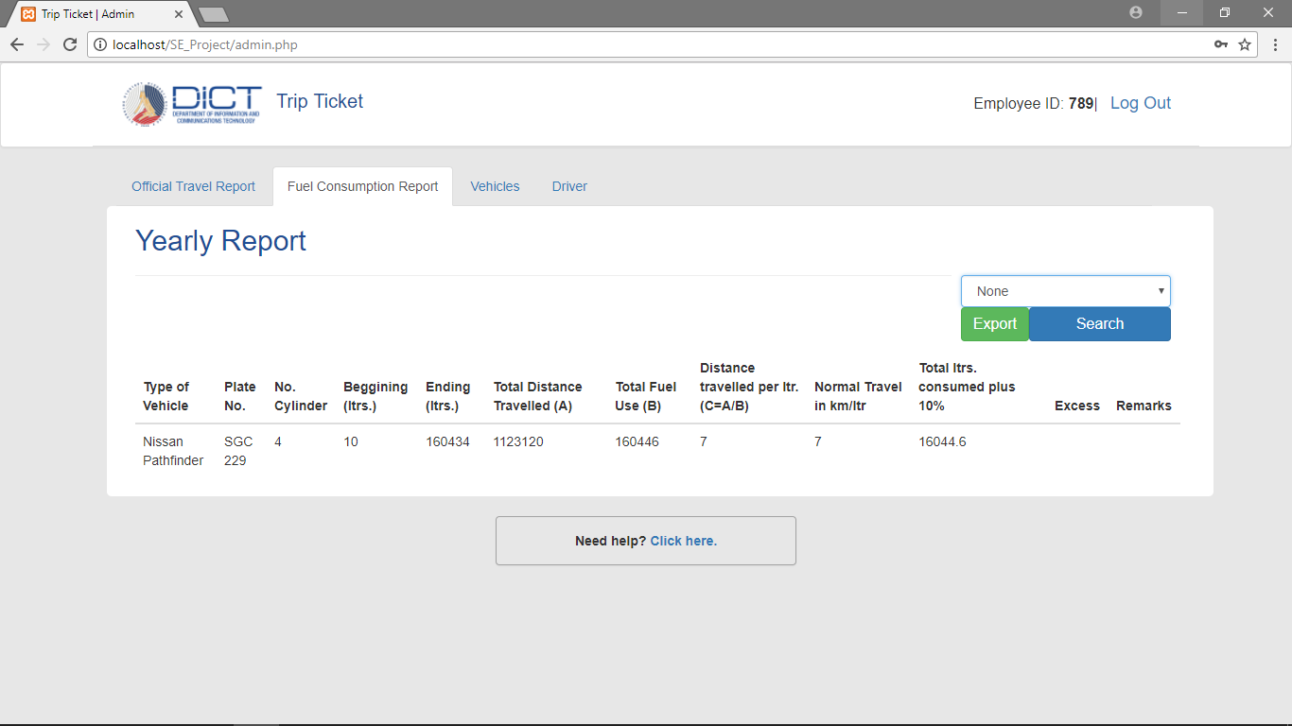

* Vehicles tab:

In this tab, you will see a list of vehicles. You can add a new vehicle if ever new vehicles will arrived in the future and also edit the vehicle’s balance in tank and it’s consumption in kilometer per liter.

1. To add, click the add vehicle button. A prompt will display and you need to fill-in all the empty fields since it is all required.

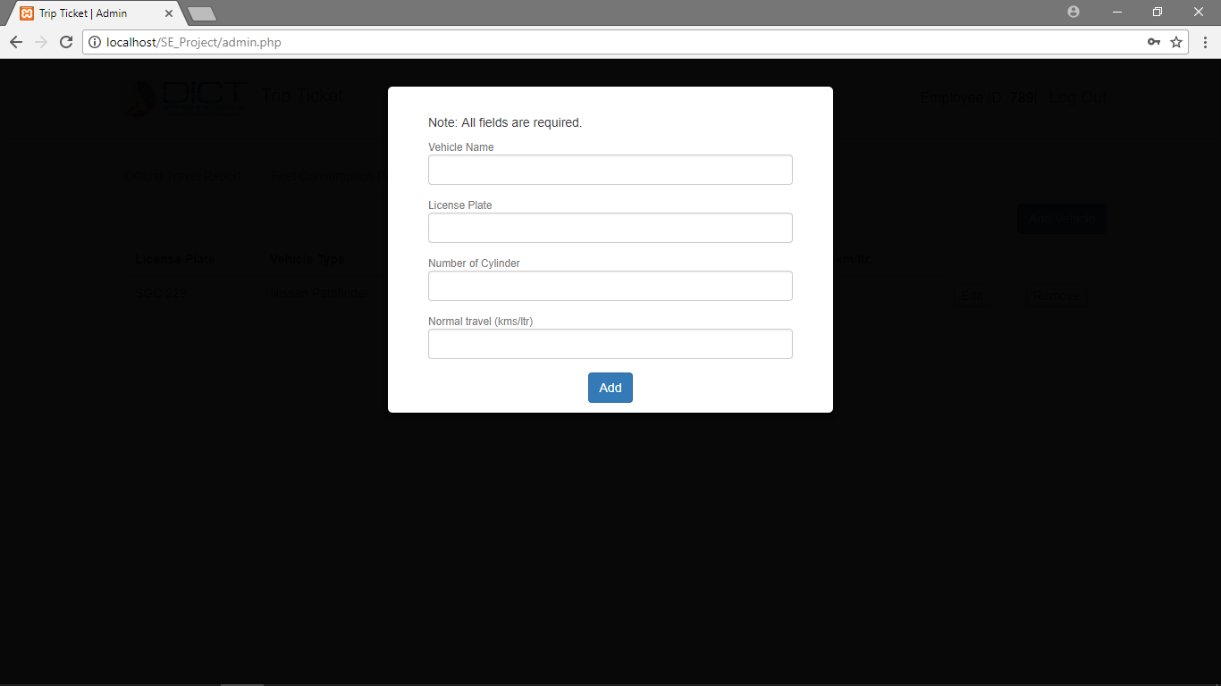

1. After adding a new Vehicle, you must set the Balance in Tank. To do this, click the edit button at the right corner of the vehicle’s data. A prompt will display and fill-in the empty fields. No need to fill-in the normal travel (km./ltr.), do this if ever the vehicle has been upgraded. Setting the balance in tank of the vehicle is only needed at the first set-up. This is important because it will be reflected on the trip ticket.

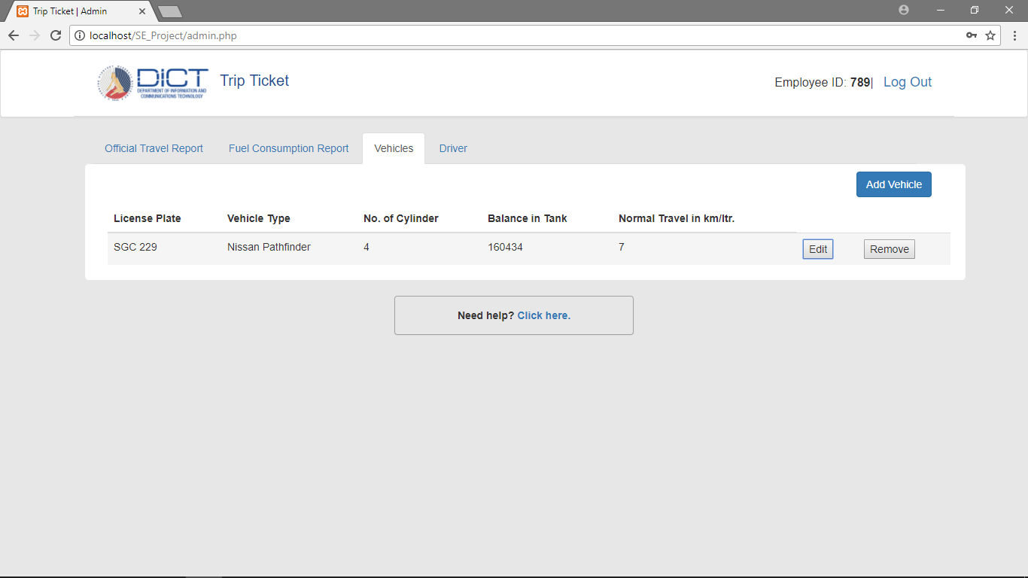

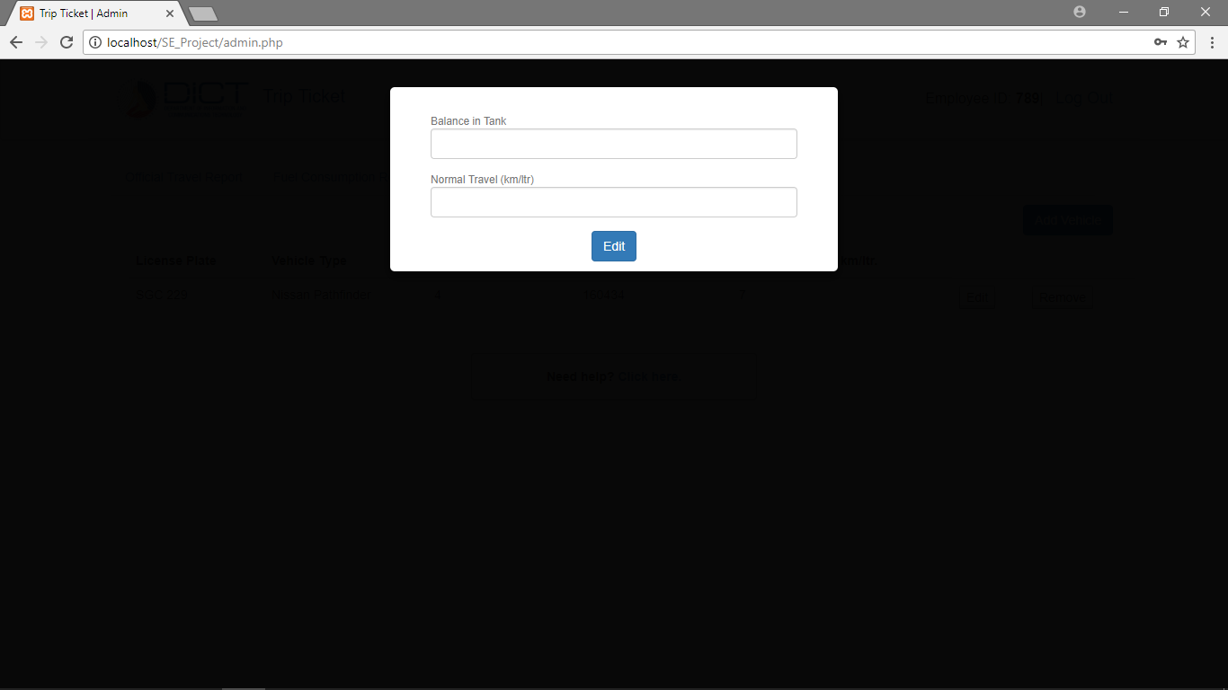

1. If a vehicle is no longer used or is unavailable, click the remove button.

* Driver tab:

You can also view all the drivers using the system and also remove them if ever they are no longer using the system. Click the delete button to do so.

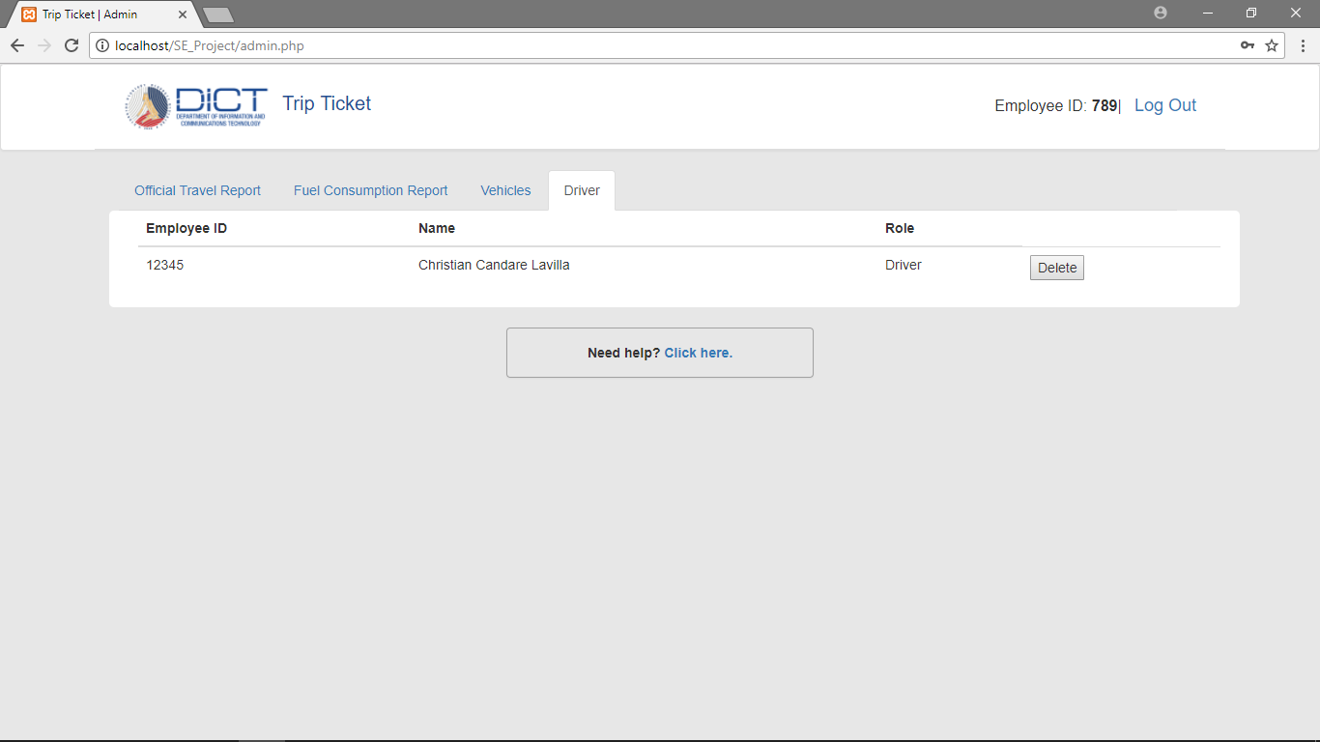

**Driver**

1. If you do not have an account yet, create one by signing up.

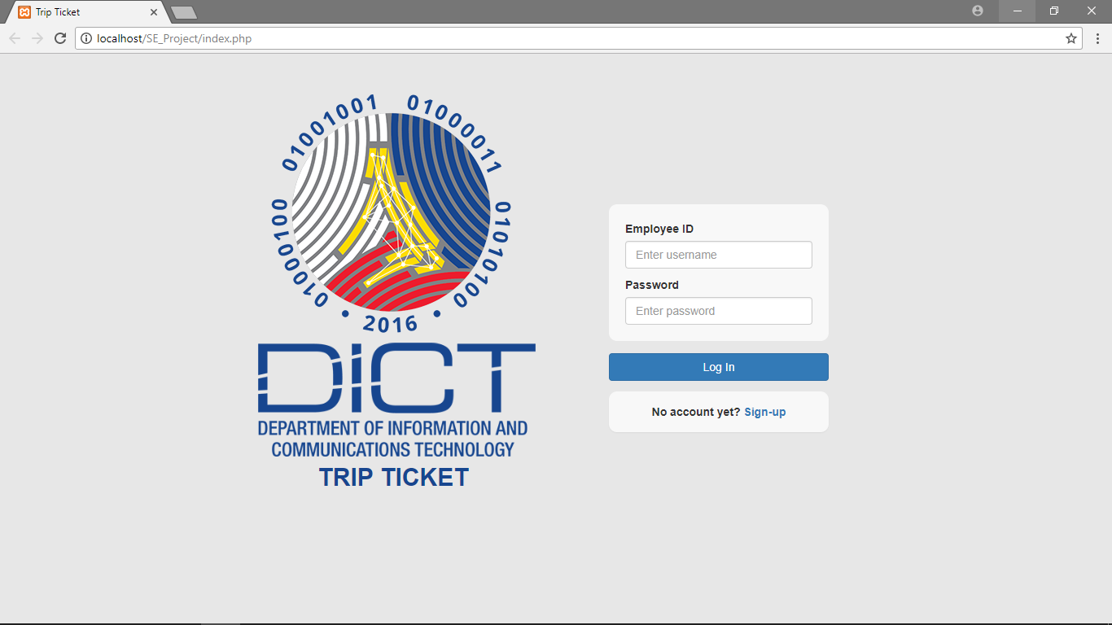

*(Click sign-up)*

1. Fill-in all the required fields and choose driver button.

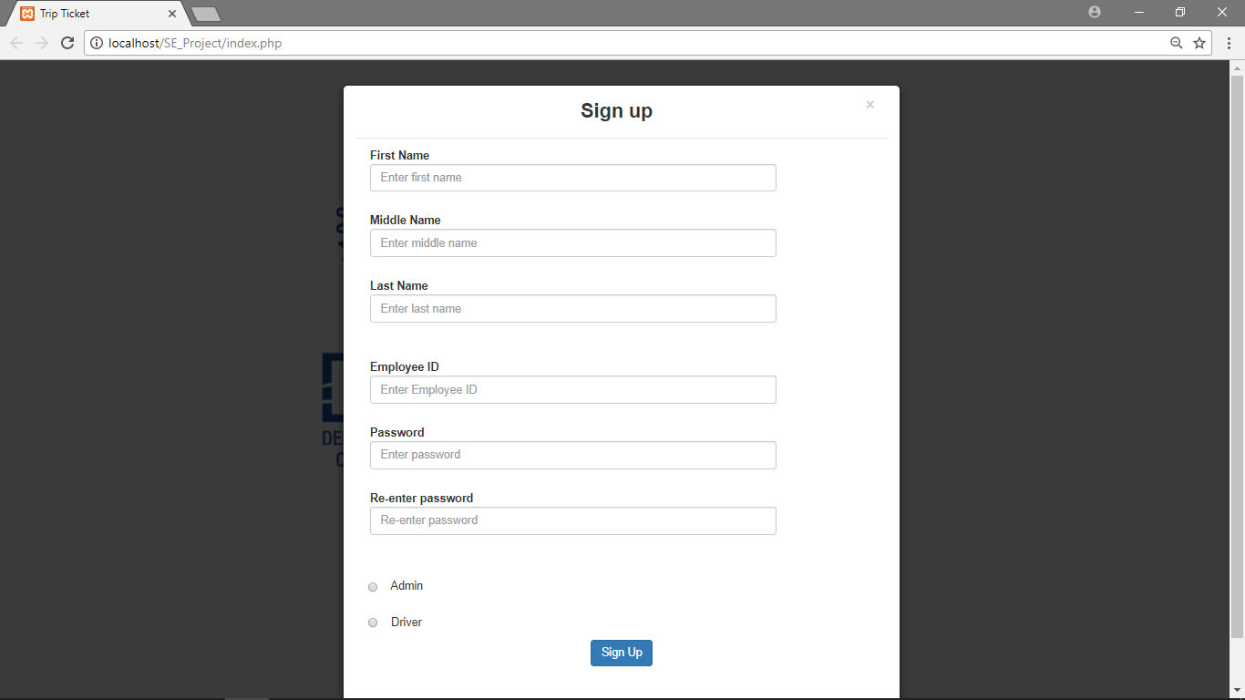

1. After signing up you can now log-in to your account.
2. Fill-in first the approval tab if you are going to print your trip ticket for approval.

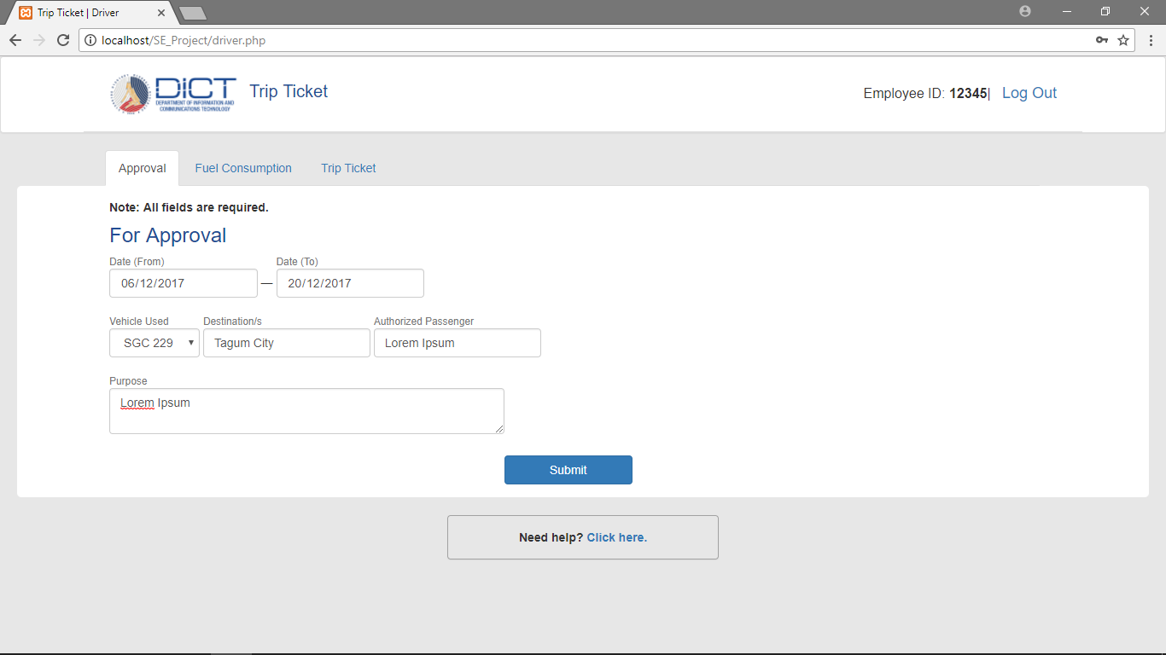

*(All fields required)*

1. After clicking submit, a prompt will display for you to review what you have done. If no changes are to be made, click print.

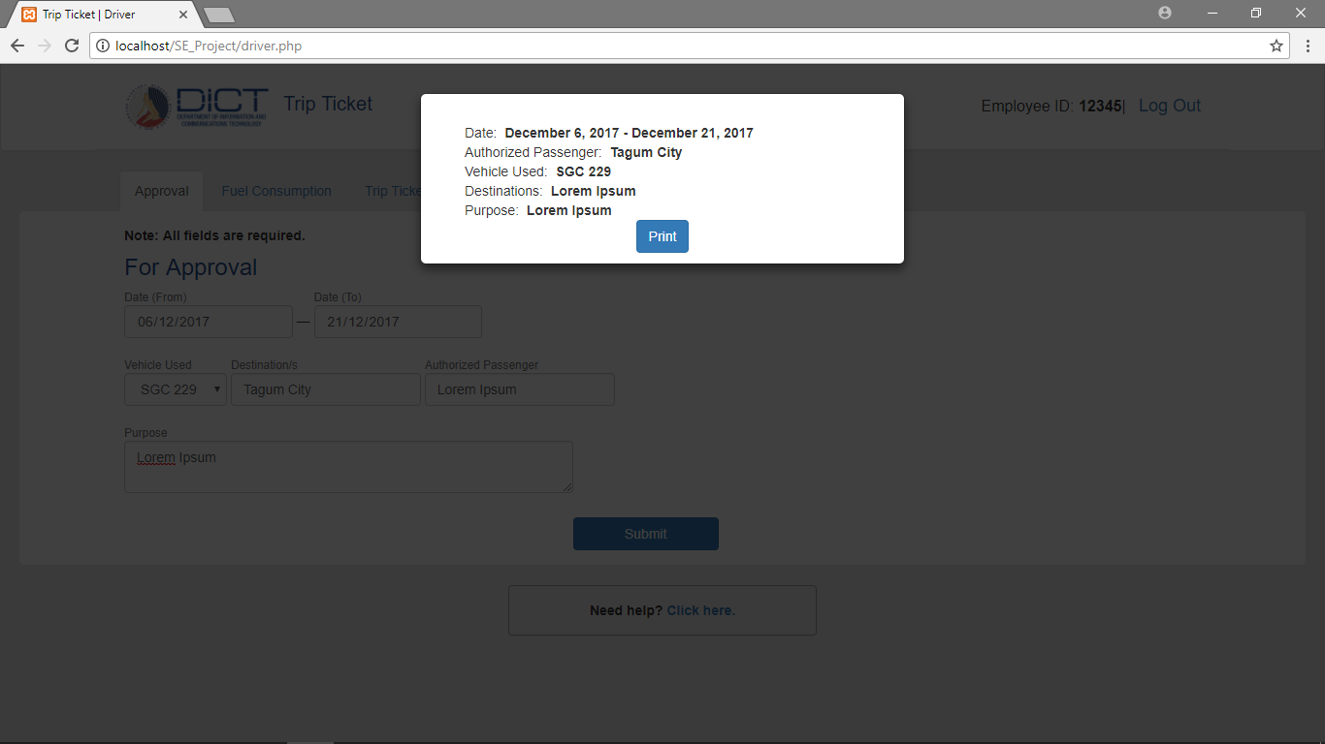

1. You will be redirected to another page with the generated trip ticket. To print this, right click then click print.

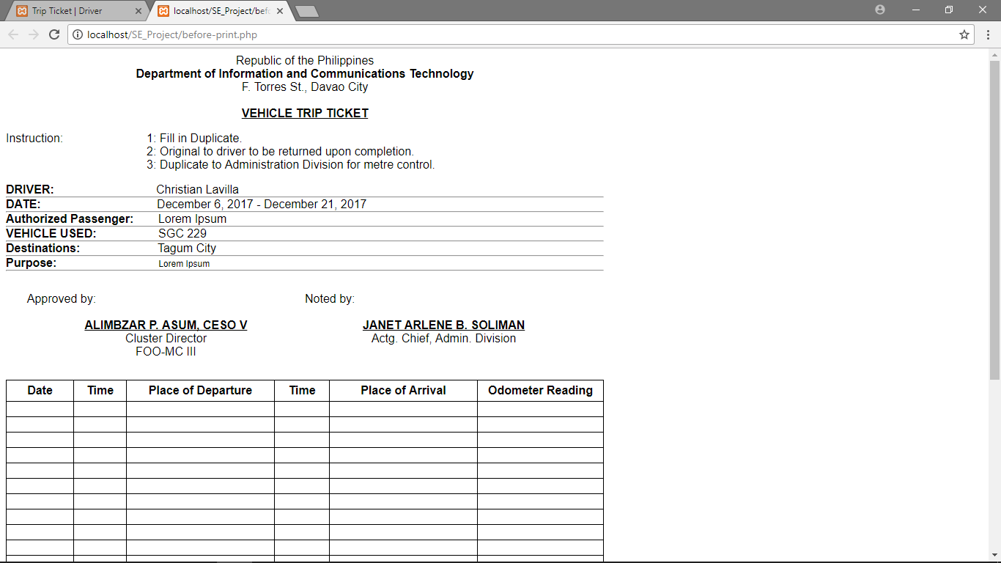

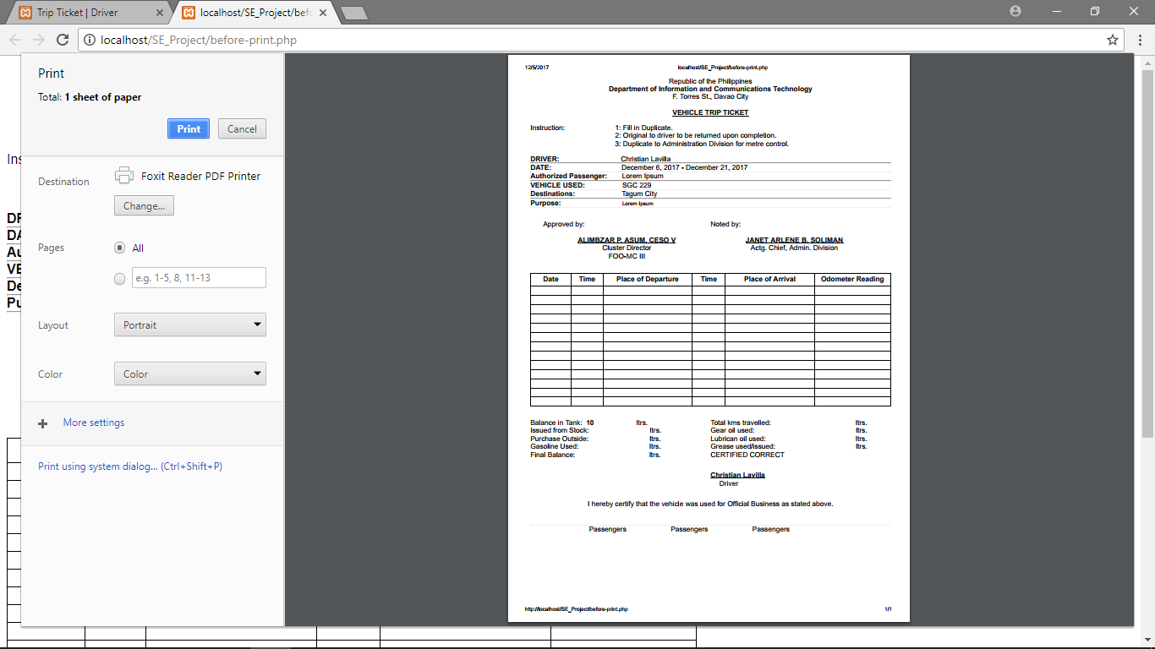

1. After the trip, proceed to the Fuel Consumption Tab. Encode the data that’s within the physical Trip Ticket.

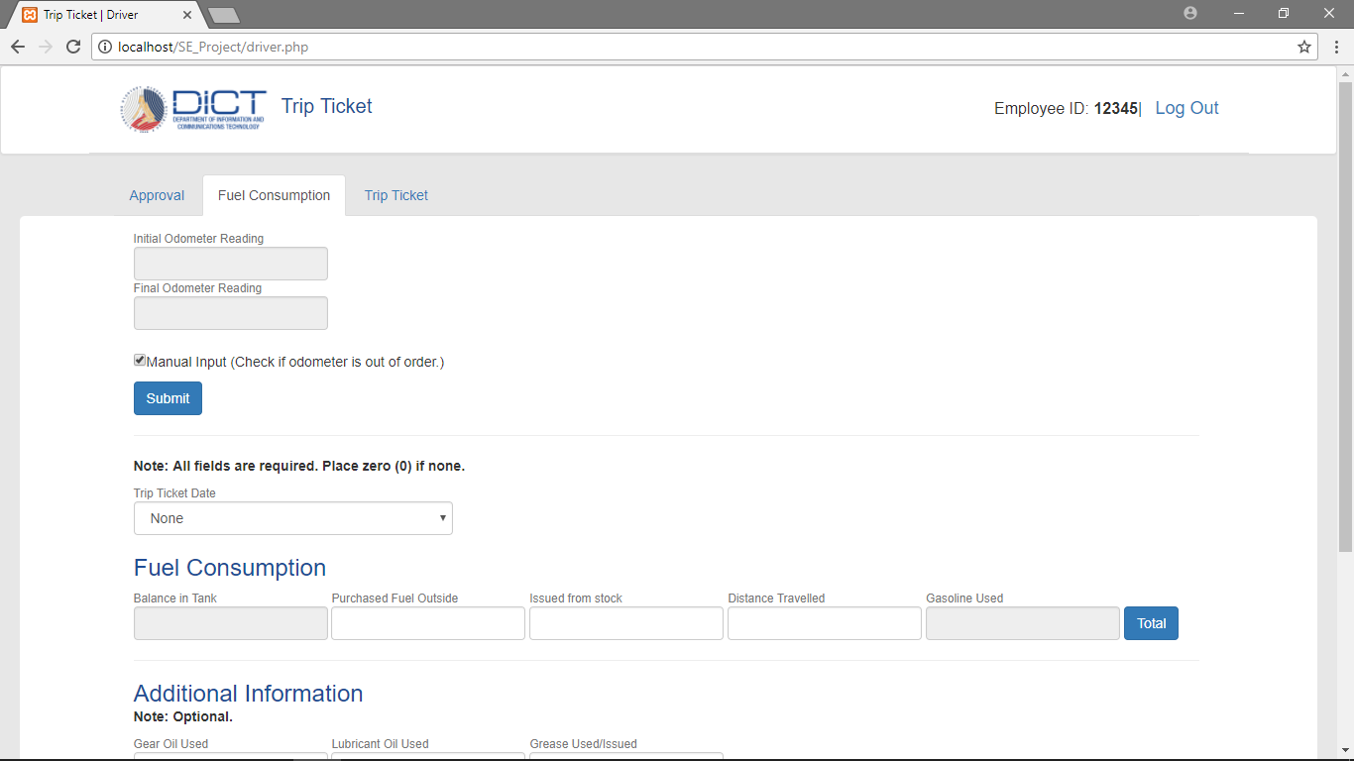

*(You will notice that if the box is checked, distance travelled below is enabled, if it is unchecked then distance travelled will be disabled)*

If an odometer reading is available uncheck the box and input the initial odometer reading and the final odometer reading. Click submit button and it will automatically calculate the total distance travelled and be reflected below. If odometer reading is unavailable, you need to manually input the distance travelled.

1. Choose the Trip Ticket Date that you wish to store the data. You will notice that balance in tank will automatically be filled-in. Enter the remaining data into the fields. You cannot left the fields in the fuel consumption to be empty, all those data is required. If done, click total for the gasoline used to be calculated automatically.

Additional Information is optional and may be left empty.

1. After filling up all the required fields, click Submit. A prompt will be displayed and you can review the data you have inputted. If no changes are to be made, click submit.

